**Leader Overview**

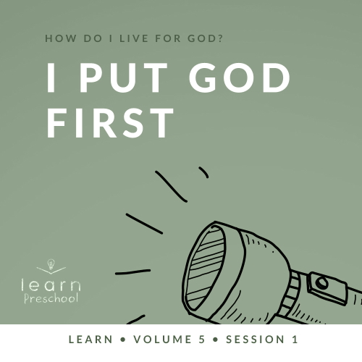

**Volume Overview**

**How do I live for God?**

*As we learn how to live for God, we’ll explore what that looks like in our everyday life. We know the Bible speaks to us, and God wants each of us to live connected to other believers. So, if that’s all true, how do we put God first? How do we get through all the confusion and uncertainty in this world? What does God expect when it comes to giving? How can we show others we care? In these sessions, we’ll consider what the Bible has to say in response to very important questions like these*.

**Session Overview**

**I Put God First**

*In this* **Learn** *session, preschoolers will discover what it means to put God first. Throughout the New Testament, Jesus used stories as illustrations, like the one from today’s session, to help explain kingdom principles. Through the words of Jesus, preschoolers will learn that many special things can seem like treasures here on earth, but God will take care of them when they put Him first*.

**Bible Lesson**

Treasures in Heaven

[Matthew 6:19–34](https://ref.ly/logosref/Bible.Mt6.19-34)

**Faith Fact**

I put God first.

**Faith Verse**

[Matthew 6:33](https://ref.ly/logosref/Bible.Mt6.33) (NLT)

“Seek the Kingdom of God above all else, and live righteously, and he will give you everything you need.”

**Preparing for the Session**

**Leader Preparation Time: 20–25 Minutes**

|  |
| --- |
| ***You Will Need***  ***Preservice Activities***  *•* ***Bible Story Warm-Up Page***  *• Cake roll snack cakes, one per kid*  *• Colorful cereal or candies*  *• Small plates, one per kid*  *• Sharp knife*  *• Toys*  ***Large Group***  *• Bible*  *• Worship songs (Song suggestions: “What a Mighty God We Serve” by Listener Kids; “Brave” by Saddleback Kids; “No Fear in Love” by Elevation Church Kids)*  *• For groups not using a phone or tablet only, add:*  *• Projector or TV*  *• Laptop*  *•* ***Faith Fact Sound*** *video (bell ringing)*  *•* ***Faith Fact Slide***  *•* ***Faith Verse Slide***  *•* ***Bible Lesson Video A***  *•* ***Bible Lesson Video B***  ***Small Group***  *•* ***Small Group Activity Page****, one per kid*  *• Crayons or markers*  *• Twenty small balls (table tennis balls, ball pit balls)*  *• Three small buckets*  *• Painter’s tape*  *•* ***Hands-On Learning Page****, one for every two kids*  *• Light green copy paper (or a color that matches local currency)*  *• Scissors*  *• New dollar bills, one per group*  *• Worn dollar bills, one per group*  To access session content and videos from a computer, visit: [BibleEngagementProject.com/downloads](https://bibleengagementproject.com/downloads) |
| ***Getting Ready***  ***Preservice Activities***  *• Set out toys and snacks.*  *• Print copies of the* ***Bible Story Warm-Up Page****, one per every ten kids.*  *• Cut apart the numbers so each kid can have one.*  *• Cut cake rolls in half horizontally and place each one on a plate.*  *• Optional: Make a sample Treasure Treat snack.*  ***Large Group***  *• Download videos and slides if needed.*  *• Select worship song(s) and have them ready to play.*  ***Small Group***  *• Practice singing the Faith Fact song to the tune of “Three Blind Mice.”*  *• Print copies of the* ***Small Group Activity Page****, one per kid.*  *• Place two pieces of painter’s tape on the floor far enough apart for two teams to sit or stand on.*  *• Place a bucket with ten balls in it at the start of each tape line.*  *• Place the third bucket an equal distance away from the end of each line so kids will run to it.*  *• Print copies of the* ***Hands-On Learning Page*** *on the light green paper, enough for each kid to have play money.*  *• Cut apart the pretend pieces of money.*  *First time leading* Learn *for Preschool? Check out the* [Facilitator Guide](https://0b769b0ed3569ef9d18b-f88d8272f61086866d50d048b43ef630.ssl.cf2.rackcdn.com/sites/biblengagementproject/Listen_Facilitator_Guide.pdf). |

**Preservice Activities**

*See what’s needed at the beginning of the session.*

**Bible Story Warm-Up**

*As kids are coming in, hand them a number slip and have them sit in a circle*.

Today, we’ll learn who should be first in our life. Have you ever been the line leader at school or here at church? *(Group response)* What happens when you’re the line leader? *(Allow responses.)* That’s right, everyone follows you. Wherever you go, they go. Everything that you do, they do. You help take care of the people following you and make sure they get to the right place.

Speaking of the right place, I gave each of you a number when you came in. Let’s line up in the right order.

• *Help kids line up in numerical order*.

Great job! Now that we’re all lined up, our line leader gets to show us what to do, and we’ll follow.

• *Let the kid with number 1 lead the group, but don’t let other kids have a turn right now*.

Good job! Now, I want you to sit down in order.

• *After the kids are seated, ask these questions*.

Did you enjoy following the leader?

Did you want a turn to be the leader?

Do you know who should be leading us?

You’re right. God should. When we live for God, we put God first. One way we can do that is to think about Him before we do anything—before we play, before we go to school, before we spend time with our friends. I can’t wait to learn more about how to put God first. How about you? *(Group response)*

**Snack**

**Treasure Treat**

*As kids are preparing the snack, share the following:*

Today, we’ll talk about treasure, so I thought it would be fun to make treasure treats.

• *Give each kid a cake roll snack on a plate*.

• *Add some cereal to the plate, and allow kids to fill their cake roll with it*.

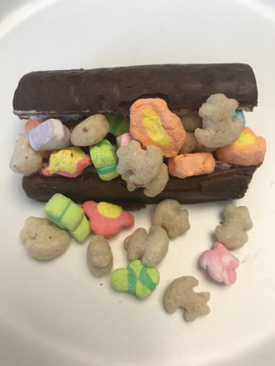

Do you have a place where you keep things that are very special to you? *(Group response)* Those special things are like treasures. Have you ever had one of your special things get broken or lost? *(Allow responses.)*

Even when we try our best to keep special things safe, sometimes they break or get lost. Today, we’ll learn about where we can store something special so it will never get lost or broken.

**Free Play**

*Any extra time can be spent playing with toys*.

**Transition**

*A few minutes before service begins have kids make their way to the large group area and sit in their designated areas*.

**Large Group**

**25 Minutes**

*See what’s needed at the beginning of the session.*

**Introduction**

Hi, friends! We’re going to have so much fun learning from God’s Word together. *(Hold up the Bible.)* If you’re excited to be here, raise your hand. *(Group response)*

Today, we’ll learn an amazing lesson that Jesus taught long ago. Jesus used to walk and talk with people just like you and me. One day He began to tell people what the most important thing to them should be. He talked about how special things on this earth, like our toys, would eventually break, but when we put God first, He takes care of us.

**Faith Fact**

That’s right! When God is most important to us, we put Him first. That’s our Faith Fact for today. **I put God first**. Can you say that with me? **I put God first**.

• *Show the* ***Faith Fact Slide***.

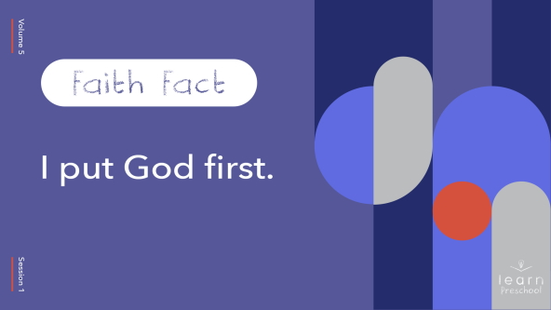

Let’s practice our Faith Fact. I’ll go first, and you repeat each word after I say it. **I put God first**. Good job!

Now, let’s try it in slow motion. **I put God first**. Let’s say it one more time, as fast as we can. **I put God first**.

You’re awesome! Do you know what it means to put God first? *(Allow responses.)* It means we should think about Him before we do anything—before we get out of bed, before we play, and before we eat. He wants us to think about Him when we’re with other people, so we are kind to them.

It’s not always easy to remember to put God first, is it? *(Group response)* Sometimes we get busy doing other things, and we might forget. When we put God first, He takes care of the rest.

**Bible Time**

The Bible is the most important and best way for us to learn about God and how He wants us to live. I can’t wait to see what Lizzy has for us today. Let’s watch together.

• *Play* ***Bible Lesson Video A***.

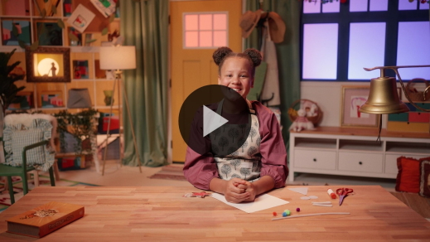

Wow! You did a great job helping Lizzy with all the clues. We learned exactly where we can store up our treasures—in heaven. When we put God first, He will take care of us just like He takes care of the birds and flowers. You are way more important to God than the flowers and birds. Isn’t God amazing? *(Group response)*

**Worship**

We can put God first when we worship Him. Sometimes we might be distracted by our friends. When we choose to put God first as we worship, we focus on Him. Worship is a lot more than singing loud; it’s about living loud. We do that when we live for God and put Him first.

**Praise**

Are you glad God leads us? Show me two thumbs-up. *(Group response)*

Are you going to put God first? Point up high. *(Group response)*

Who wants to tell God you love Him? Wrap your arms around yourself like a big hug. *(Group response)*

**Sing**

Now is our chance to tell Him how much we love Him. Let’s take these next few minutes and focus our heart and mind on Him. Let’s put God first as we worship Him and sing.

• *Lead the kids in singing one or two songs. See song suggestions at the beginning of the session*.

**Prayer**

I love listening to you worship God, but did you know there is Someone who loves listening to you worship even more that I do? *(Group response)* God loves to hear you worship Him. You did such a good job worshipping today. Before we move on, let’s take a minute to stop and talk to God. Let’s bow our heads and pray.

|  |
| --- |
| Dear God, thank You for always taking care of us. Help us to remember that we can trust You. We’ll do our very best to put You first, but when we forget, please remind us. We love You so much. Amen. |

**Bible Time cont’d**

The Bible tells us a lot about trusting God and putting Him first. That reminds me of our Faith Verse. Let’s watch this video and learn our Faith Verse with Lizzy.

• *Play* ***Bible Lesson Video B***.

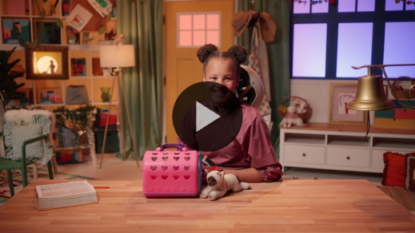

Fantastic! You’ll have our Faith Verse memorized in no time. This verse is a great reminder that when we put God first, He takes care of us. When it gets hard to put God first, this verse will help you remember why it’s so important. That’s why we’re learning it together.

**Response Time**

• *Play a worship song quietly*.

Can anyone remember where Jesus said we should store our special treasures? *(Allow responses.)* That’s right! We store them in heaven.

Let’s take some time to respond to God. When we respond to God, we stop and think about what we’ve learned. Then, we talk to God about it. Everyone, point up with your pointer finger. *(Point up with your index finger)*. This means number one, and it can help us remember to put God first. Let’s keep pointing our finger as we pray and ask God to help us remember to put Him first.

• *Optional: Have the kids repeat phrases of the prayer after you*.

|  |
| --- |
| Dear God, I will put You first. Sometimes it’s hard, but I want to put You first always. Please help me. Thank You for always being with me. Amen. |

**Faith Verse**

Did you know God loves it when we learn Bible verses from His Word? Let’s say our Faith Verse and do the actions together.

• *Show the* ***Faith Verse Slide***.

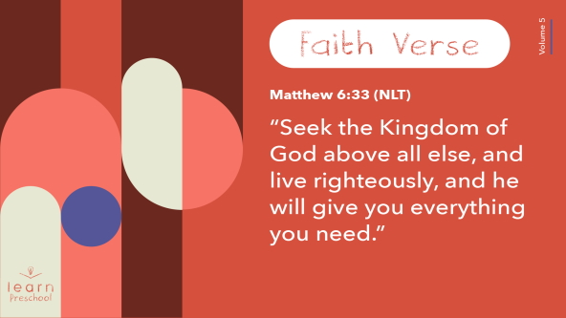

[Matthew 6:33](https://ref.ly/logosref/Bible.Mt6.33) (NLT)

“Seek the Kingdom of God above all else, and live righteously, and he will give you everything you need.”

**Matthew** *(hands at waist, spread apart, palms up and out)*

**6**: *(hands together like a clap)*

**33** *(hands opened to “book”)*

**“Seek the Kingdom of God** *(one hand at brow, “search” left and right)*

**above all else**, *(point up with both index fingers)*

**and live righteously**, *(clasp hands in prayer waist-high)*

**and he will give you** *(open hands flat at waist)*

**everything you need.”** *(move hands out to side and then clap)*

Wow! You’re doing so well at learning our Faith Verse!

**Closing**

Did you have fun learning more about God today? *(Group response)* Me too! I loved worshipping, praying, and praising together. We‘ve learned that we can put God first. Our Bible story taught us that God will always take care of us even better than He takes care of the birds and the flowers.

• *Play the* ***Faith Fact Sound*** *video (bell ringing)*.

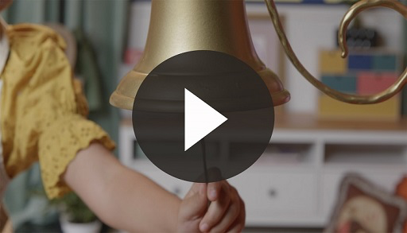

Did you hear that? *(Group response)* That sound means it’s time to practice our Faith Fact again.

• *Show the* ***Faith Fact Slide***.



Let’s shout it together. Ready? **I put God first**. Let’s declare this. Every time we say a word, punch up your fist into the air. *(Demonstrate fist pump the air.)* Are you ready? **I put God first**.

**Dismissal to Small Groups**

Awesome! Now, it’s time to head to our circles for small groups as we keep having fun and learning to put God first.

• *Dismiss the kids by groups*.

|  |
| --- |
| ***Leader Tip:*** *This can be done by assigning color teams or by age groups. Note that some young preschoolers may not know their age. Using a colored sticker, jersey, or wristband will help separate the kids and help identify their small groups.* |

**Small Group**

**25 Minutes**

*See supplies and prep instructions at beginning of session or in each activity below.*

|  |
| --- |
| ***Leader Tip***: *Small groups can alternate to each circle, or all groups can do each activity at the same time. If you choose to alternate, you will need at least one leader per circle.* |

**Circle 1**

**Group Connection**

**Sing Along!**

Who can tell me our Faith Fact for today? *(Allow responses.)* That’s right. **I put God first**.

I have an awesome song I want to teach you to help you always remember our Faith Fact.

• *Sing to the tune of “Three Blind Mice.”*

How do I live for God?

How do I live for God?

I put God first!

I put God first!

I read my Bible to help me grow

And help me know which way to go.

I put God first!

I put God first!

Great job singing! Let’s sing it again!

• *Repeat the song two to three more times*.

You did amazing at learning this new song to help us remember our Faith Fact. Let’s say the Faith Fact all together. **I put God first**.

**Circle 2**

**Activity Page Time**

**All Day Long with God**

|  |
| --- |
| ***You Will Need***  *•* ***Small Group Activity Page****, one per kid*  *• Crayons or markers*  ***Getting Ready***  *• Print copies of the* ***Small Group Activity Page****, one per kid.* |

Today, we learned that we can put God first. We can do that all through the day.

• *Give each kid a* ***Small Group******Activity Page*** *and crayons*.

On your Activity Page, you’ll see different activities you probably do every day. One of them definitely shows us how we can put God first. Which one is it? *(Allow responses.)* Praying before we eat is a great way to put God first and thank Him for our food. As you color the different activities, let’s think of how you can put God first during that time of day.

What are some ways that you can you put God first in the morning before you brush your teeth? *(Allow responses.)*

How can you put God first when you’re playing with friends? *(Allow responses.)*

When you get ready for bed, is there a way to put God first? *(Allow responses.)*

These are all great answers! Take this home and hang it somewhere you’ll see it every day. You can hang it on your door or on the bathroom mirror. Let it be a reminder to put God first.

• *During the activity, interrupt and practice the Faith Fact*. **I put God first**.

• *Play the* ***Faith Fact Sound*** *video. Review the Faith Fact even if you can’t play the sound*.



**Circle 3**

**Feet-to-Floor Game Time**

**Pass the Fact**

|  |
| --- |
| ***You Will Need***  *• Twenty small balls (table tennis balls, ball pit balls)*  *• Three small buckets*  *• Painter’s tape*  ***Getting Ready***  *• Place two pieces of painter’s tape on the floor far enough apart for two teams to sit or stand on.*  *• Place a bucket with ten balls in it at the start of each tape line.*  *• Place the third bucket an equal distance away from the end of each line so kids will run to it.* |

We have a fun game that’s going to help us remember our Faith Fact. Let’s say it. **I put God first**. Who’s ready for some fun? *(Group response)* We’re going to play with two teams.

• *Form two teams and have each team’s kids sit or stand side by side on the tape strip*.

This is a race to pass our Faith Fact. The first person in line will take one ball out of the bucket and pass it to the person next to them. When you pass it, be sure to say our Faith Fact: **I put God first**.

When it gets to the last person, they’re going to run and put the ball in the empty bucket. Then, they’ll run to the front of the line. They get to be the new line leader and get a new ball out to pass. The first team to get all of the balls out of their bucket and into the other bucket wins.

• *Play until one team wins*.

Wow! You were so fast! Great job! You practiced your Faith Fact while having fun.

• *Play again if you have time*.

**Circle 4**

**Hands-On Learning**

**New or Worn**

|  |
| --- |
| ***You Will Need***  *•* ***Hands-On Learning Page****, one for every two kids*  *• Light green copy paper (or a color that matches local currency)*  *• Scissors*  *• New dollar bills, one per group*  *• Worn dollar bills, one per group*  ***Getting Ready***  *• Print copies of the* ***Hands-On Learning Page*** *on the light green paper, enough for each kid to have play money.*  *• Cut apart the pretend pieces of money* |

We’ve been talking about treasure today. Sometimes when people hear the word *treasure*, they think about money. So, I’m going to give each of you some.

• *Give each kid some play money*.

When you look at this money, what do you see? *(Allow responses.)* What does it feel like? *(Allow responses.)* What can you buy with your money? *(Allow responses.)*

We can’t buy anything with this money because it’s not real. In fact, it would probably be pretty easy for me to tear it.

• *Tear a fake bill in half*.

• *Hold up a new dollar bill, the real money*.

What about this one? I’ll pass it around, so you can feel it and look at it more closely.

• *Allow kids to pass it around and touch it*.

I could tear it like the other one, but do I want to? *(Group response)* No, I wouldn’t want to do that because it’s real money. I could buy something with this money. What could I buy? *(Allow responses.)* Those are good ideas!

• *Hold up the worn dollar bill*.

How about when money gets worn out? Should I tear it now? *(Group response)* Can I still buy something with it? *(Group response)* This money is still good for buying things, but over time money gets worn out from people touching it.

I could buy the same things with this worn dollar bill that I could buy with the new, crisp money. Even the things I buy will get worn out or eaten up. This is why God tells us it’s important not to store up our treasures on earth but in heaven. We do that by putting God first. No matter how much money we have or what we buy with it, nothing on earth is as important as God. What does our Faith Fact say? **I put God first**.

I’m so thankful that when we put God first and focus on the things that matter to Him, those things don’t get worn out or broken. The special things we have will eventually get worn down or broken, but God is always with us.

**Dismissal**

• *Play the* ***Faith Fact Sound*** *video (bell ringing)*.



• *Show the* ***Faith Fact Slide***.



Everyone, freeze! I just heard our Faith Fact sound. Before you leave, let’s say our Faith Fact together one more time. Reach up high and grab your big loud voice. We’re going to say this as loud as we can. Ready? **I put God first**.

• *Send home the* ***Small Group Activity Page*** *and play money with each kid*.

• *Remind parents that there are* ***Family Devotions*** *available on the app to do with their kid*.

• *Tell everyone the date and time for the next session*.